Classifying Bike Parking

Short-term bike parking (AKA Class II) is needed where bicycles will be left for short stops around two hours or less. It requires a high degree of convenience (within 50 feet of the main entrance). Due to the weather in Erie, short-term bicycle parking should be protected from the weather whenever possible (a portion can be unprotected, since demand tends to increase during dry weather).

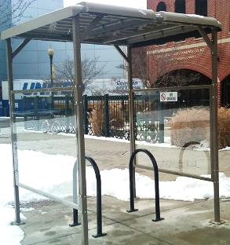
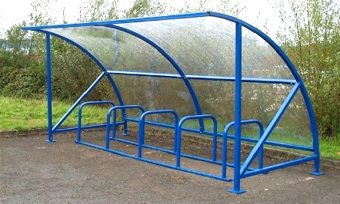
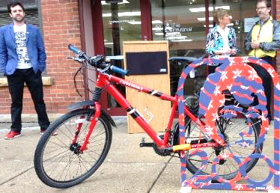
Examples:

Long-term bike parking (AKA Class I) is needed where bicycles will be left for many hours at a time such as places of employment. Long-term bike parking requires a high degree of security, and weather protection with well-designed racks in covered areas, lockers, storage rooms, or fenced areas with restricted access.
Examples:
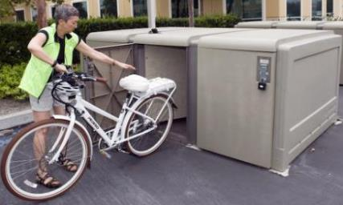
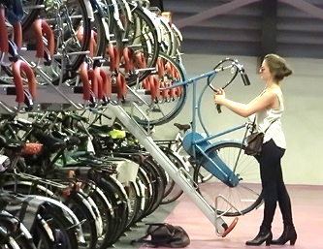
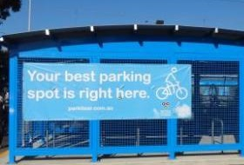

Unsuitable racks that don’t meet best practices
Comb, toast, wave, and other wheel-bending racks provide no support for the bicycle frame and are NOT recommended. These racks leave bicycles vulnerable to damage which led to the nickname “wheel bender.” These racks can be very impractical as people who bike are forced to drape their bikes over them in order to use a U-lock. This cuts the rack’s capacity in half. The wave style rack does not provide two points of contact with the bike frame and bikes end up tipping over into the sidewalk or become packed too tightly together causing damage.

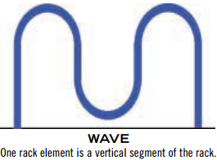
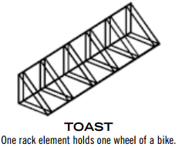
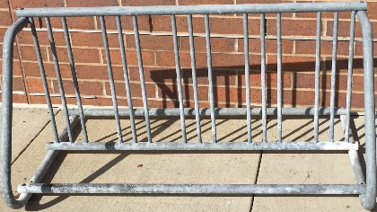
Examples:

Bike Parking Assessment
Location: _____________________________________________________
Facility / Building ID: _________________________________
Make sure to take photos of bike rack / parking (get multiple angles)

- This facility/building /location has bike rack/bike parking? Yes or No
Number of racks: ___________________

Size of rack(s) (measurement and photos):_____________________________

- How you would classify the bike rack(s) / bike parking? (Refer to classification on page 1)
- Unsuitable bike rack(s) – does not meet best practices
- Class II uncovered
- Class II covered
- Class I outdoor
- Class I indoor

- Check all that apply
- The rack element supports the bicycle and holds the bicycle frame (not just a wheel), which allows the frame and both wheels to be secured
- The rack is or parking element is secured to the ground or floor in a way that is not easily removable
- The rack element is strong and can resist being cut or detached using common hand tools, especially those that can be easily carried and concealed (bolt cutters, pipe cutters, wrenches, etc.)
- The rack accommodates a wide range of bicycle frame types (e.g., mixte and foldable frames), sizes, and wheel sizes
- The rack can be used with a U-lock
- The rack does not have hazards, such as sharp edges

Any other important information:

- Is the bike rack/bike parking location suitable? Yes or No
Suitable location checklist:
- Good visibility and accessibility (both class II and class I)
- Short distance from main entrance (short-term, class II parking)
- Does not interfere with doors opening or other key areas (both classes)
- Located on a sidewalk, path or cement pad where there is adequate clearance for pedestrian traffic
- Does not interfere with ADA regulations
- Rack or parking area is covered/protected from most or all weather
- Indoor/caged parking is signed and it’s apparent what and where they are
- Long-term parking is near shower/changing facilities and/or is in a centrally accessible and convenient location
- Does not majorly interfere with snow removal (won’t be removed/damaged)
Description of why not:

- Does the building/location have enough bike racks/bike parking based on Victoria Transportation Policy Institute's Bicycle Parking Guidelines? Yes or No

Bicycle Parking Requirements (Litman, et al, 1999)
Land Use | Bicycle Spaces Required | Type
RESIDENTIAL
Single family / two family | N/A | N/A
Apartment / Townhouse | 1 per unit plus 6 space rack at each building entrance. | Class I 100%  Class II 6 space rack
COMERCIAL
Hotel / Motel | 1 per 15 rooms. In addition, when hotel/motel is greater than 75 rooms, a 6 space visitor rack shall be provided | Class I 60%  Class II 40%
Office, retail sales of goods and services, restaurants, research establishments, laboratories | 1 per 250 m² GFA for the first 5000 m² and 1 per 500 m² for any additional area | Class I 50%  Class II 50%
Shopping Centre | 1 per 250 m² of gross leasable area for the first 3000 m² and 1 per 500 m² of gross leasable area for any additional area. | Class I 30%  Class II 70%
INDUSTRIAL (ALL) | 1 per 950 m² GFA | Class I 80%  Class II 20%
INSTITUTIONAL
Hospitals | 1 per 500 m² | Class I 75%  Class II 25%
Schools | All levels: 1 per 10 employees | Class I employees college, university 10%  Class II students
Elementary | 1 per 10 students
Junior Secondary | 1 per 8 students
Senior Secondary | 1 per 8 students
College | 1 per 5 students
University | 1 per 5 students (full time, max. attendance)
Churches | 1 per 50 members | Class II 100%
Library / Museum/ Art Gallery | a per 100 m² GFA | Class I 20%  Class II 80%
Personal Care / Nursing Home / Group Home | 1 per 15 dwelling units | Class I 75%  Class II 25%
Correctional Institutions | 1 per 50 beds | Class I 70%  Class II 30%
CULTURAL AND RECREATIONAL
Community Centre | 1 per 80 m² of GFA | Class I 20%  Class II 80%
Stadium, Arena, Pool, Exhibition Hall, similar places with spectator facilities | 1 per 100 m² of surface area | Class I 20%  Class II 80%
Gymnasium, Health Spa | 1 per 80 m² of surface area | Class I 20%  Class II 80%
Bowling Alley, Curling Rink | 1 per 2 alleys or sheets | Class I 20%  Class II 80%

Minimum Bicycle Parking Requirements (Portland)
Type of Establishment | Minimum Number of Bicycle Parking Spaces
Primary or secondary school | 10% of the number of students, plus 3% of the number of employees.
College or university classrooms | 6% of the number of students, plus 3% of the number of employees.
Dorms, fraternities and sororities | One space per 3 residents.
Commercial – retail or office | One space per 3,000 sq. ft. of commercial space or 5-10% of the number of automobile spaces.
Sport and recreation center | 10-20% of the number of automobile spaces.
Movie theater or restaurant | 5-10% of the number of automobile spaces.
Industrial | 2-5% of the number of automobile spaces.
Multi-unit housing | 1 space per 1-2 apartments.
Public transit stations | Varies, depending on usage.

Description of why not:

Sources used:
- APBP: http://c.ymcdn.com/sites/www.apbp.org/resource/resmgr/publications/bicycle_parking_guidelines.pdf
- Dero: http://www.dero.com/bike-parking-guide.pdf
- VTPI: http://www.vtpi.org/tdm/tdm85.htm

