What You Need to Know About Bike Parking

Individuals who bike for transportation require different types of parking. For example, people who commute to work or school generally require indoor parking, bicycle lockers, or, at the very least, bicycle racks that are covered with a canopy or another type of shelter. Retail, entertainment, and business districts are usually best served by a combination of conveniently placed outdoor racks that are firmly secured, as well as clustered bike parking areas like bike corrals and bike cages.

Large employers, universities, housing complexes and business districts, should always consider the importance of end of trip facilities such as showers and storage. The vast majority of employees will not bike more than a couple of miles to work if showers and adequate storage aren’t available and convenient for them to use.

Key Factors to Consider When Creating Bike Parking
Location and Visibility Security Weather Protection
Siting and Spacing Amenities Type of Rack
Types of Racks to Avoid Clearance Signage

Types of Bike Parking

Short-term bike parking (AKA Class II) is needed where bicycles will be left for short stops around two hours or less. It requires a high degree of convenience (within 50 feet of the main entrance). Due to the weather in Erie, short-term bicycle parking should be protected from the weather whenever possible (a portion can be unprotected, since demand tends to increase during dry weather).

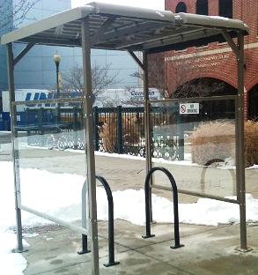
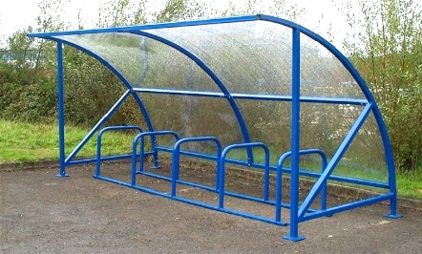
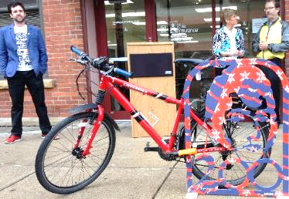
Examples:

Long-term bike parking (AKA Class I) is needed where bicycles will be left for many hours at a time such as places of employment. Long-term bike parking requires a high degree of security, and weather protection with well-designed racks in covered areas, lockers, storage rooms, or fenced areas with restricted access.

Examples:
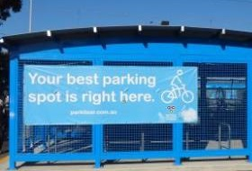
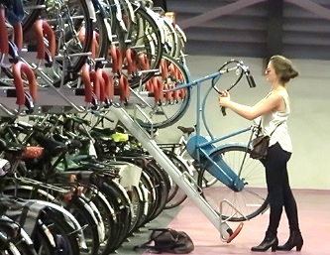
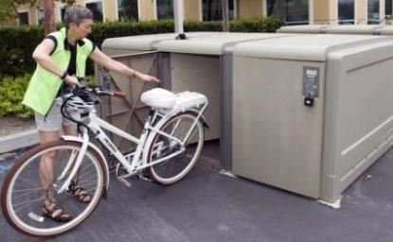

What to AVOID and/or replace
Comb, toast, wave, and other wheel-bending racks provide no support for the bicycle frame and are NOT recommended. These racks leave bicycles vulnerable to damage which led to the nickname “wheel bender.” These racks can be very impractical as people who bike are forced to drape their bikes over them in order to use a U-lock. This cuts the rack’s capacity in half. The wave style rack does not provide two points of contact with the bike frame and bikes end up tipping over into the sidewalk or become packed too tightly together causing damage.

Examples:
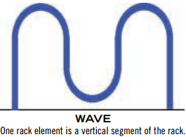
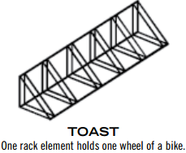
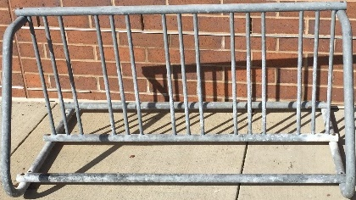

Bike Parking Options & Ideas
Short-term Bike Parking

Standard bike racks
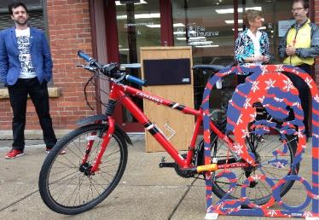
Short-term bike parking comes in many shapes, sizes and designs – from artistic racks created to showcase one’s local history and culture, to the trusty u-shaped racks that everyone is familiar with. Erie’s Perry 200 artistic bike racks were designed by local artist Todd Scalise to commemorate the Battle of Lake Erie Bicentennial. There are various artistic bike rack designs available for purchase through the Erie Art Museum and custom racks can created.
Bike Corrals
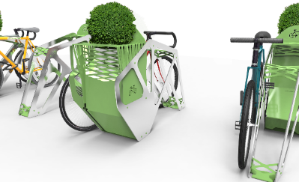
Bike corrals generally consist of multiple bike racks placed together in a close area. These planter bike racks have been installed in a group outside of Shake Shack in Philadelphia to create a bike corral which provides short-term parking for more than 10 bikes. Whether installed individually or in a group, we believe racks like these provide secure and attractive short-term bike parking. To learn more about these bike racks, which were designed by PA based design firm Shift_Design, please visit this link.

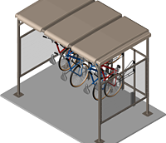
Bike Shelters
A place to park a bike with some shelter from Erie weather is certainly a desired form of bike parking and a major upgrade from an exposed bike rack. The image shows CycleSafe’s version of a bike shelter and they offer many ways to customize it. There are many companies that provide products like this shelter and you should also consider working with local architects and manufacturers and to create a solution.

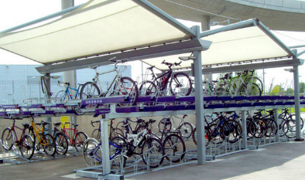
Two-tiered Parking
In many locations space comes at a premium. As a result, designs focus on building up or down rather than out. Two-tiered bike parking is a solution for those who need or desire to make optimal use of space. In many cases, tiered parking racks incorporate elements to help people lift their bikes to the upper level.

Long-term + Protected Bike Parking

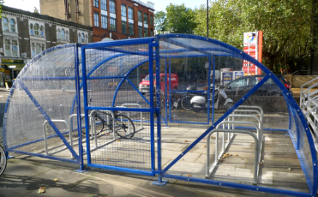
Cycle Compounds & Cages
This particular outdoor bike parking facility is called a “cycle compound” or “cycle cage”, which is designed to protect an entire bike. This particular model provides parking for 20 bikes, though “cycle compounds” can be designed and customized to hold any number of bikes. Also, due to the ever-changing weather in Erie, making the top covered would be an important customization to add. This particular shelter is designed and sold by Cyclehoop. For more details, visit this link.

Cycle “Hangers”
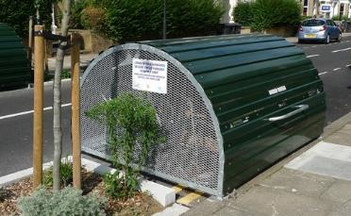
Similar to a “cycle compound”, a “cycle hanger” provides protected bike parking includes some protection from poor weather, which is essential here in Erie. Like any other bike parking facility, it can likely be customized to hold any number of bike and provide different levels of security and accessibility. This particular “cycle hanger” is made by Cyclehoop. For more details on it, visit this link.

Bike Lockers
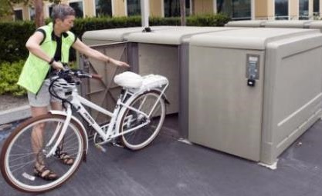
Bike lockers are great for securing the entire bicycle and have enough room to hold other small accessories. They are a great option for both short and long-term bike parking. Generally, these lockers are used for extended-term parking near transit locations like airports, as well as train and bus stations. They are also used at and around hotels and business districts, as well as in areas that have a high crime rate. Even college campuses can benefit from bike providing lockers for students to use during long breaks or semesters abroad.
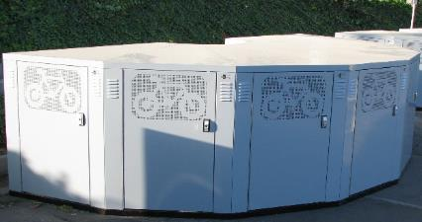
There are many models of bike lockers with various features. Some of which provide manual locking access and others have electronic keycard access. If you want to implement these on a large scale, then we encourage you to talk with multiple providers, and, perhaps more importantly, talk with the organizations that are using bike lockers to better understand what works and what doesn’t.
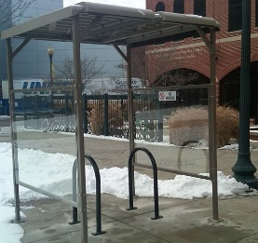
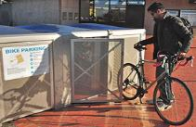
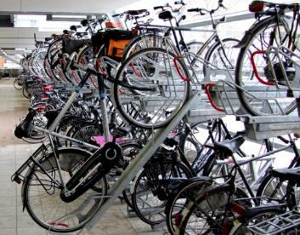
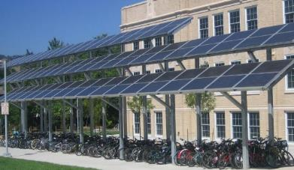
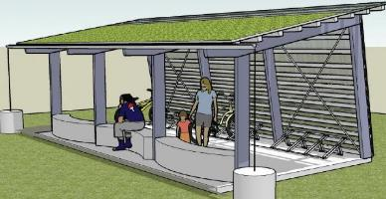
Other Examples and Ideas for Bike Parking
Covered, quickly accessible parking for two bikes
Secure bike parking in a covered bike cage with electronic keycard access at MIT.
Two-tiered indoor bike racks with assist features to help easily lift bikes.
Solar panel canopy provides sheltered bike parking installed at a school.
Bike parking cage at Monash Univeristy. Banner shows possibility for advertising.
Standard Bike corral installed in front of Kaya restaurant in Pittsburgh.
One designer’s concept of a bike shelter with a green roof, screen wall & benches.
Electronic bike lockers with keycard access at Berkeley, CA bus station.
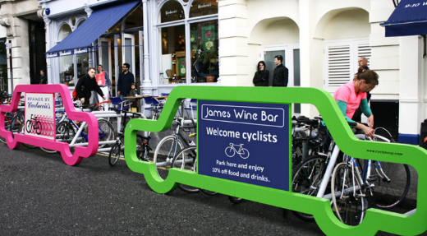
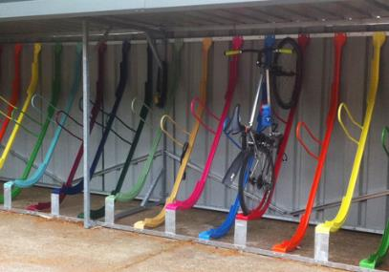
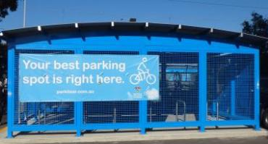
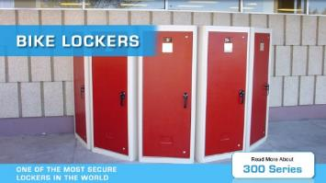
Bike lockers by American Bicycle Security Company - an entire bike fits.

Semi-vertical bike shelters provide space-saving covered parking for many bikes.
Car shaped bike corrals in business district each have advertisements and provide parking for 10 bikes vs. 1 car.

Recommended Amount of Bike Parking (Litman, et al, 1999)

Land Use | Bicycle Spaces Required | Type
RESIDENTIAL
Single family / two family | N/A | N/A
Apartment / Townhouse | 1 per unit plus 6 space rack at each building entrance. | Class I 100%  Class II 6 space rack
COMERCIAL
Hotel / Motel | 1 per 15 rooms. In addition, when hotel/motel is greater than 75 rooms, a 6 space visitor rack shall be provided | Class I 60%  Class II 40%
Office, retail sales of goods and services, restaurants, research establishments, laboratories | 1 per 250 m² GFA for the first 5000 m² and 1 per 500 m² for any additional area | Class I 50%  Class II 50%
Shopping Centre | 1 per 250 m² of gross leasable area for the first 3000 m² and 1 per 500 m² of gross leasable area for any additional area. | Class I 30%  Class II 70%
INDUSTRIAL (ALL) | 1 per 950 m² GFA | Class I 80%  Class II 20%
INSTITUTIONAL
Hospitals | 1 per 500 m² | Class I 75%  Class II 25%
Schools | All levels: 1 per 10 employees | Class I employees college, university 10%  Class II students
Elementary | 1 per 10 students
Junior Secondary | 1 per 8 students
Senior Secondary | 1 per 8 students
College | 1 per 5 students
University | 1 per 5 students (full time, max. attendance)
Churches | 1 per 50 members | Class II 100%
Library / Museum/ Art Gallery | a per 100 m² GFA | Class I 20%  Class II 80%
Personal Care / Nursing Home / Group Home | 1 per 15 dwelling units | Class I 75%  Class II 25%
Correctional Institutions | 1 per 50 beds | Class I 70%  Class II 30%
CULTURAL AND RECREATIONAL
Community Centre | 1 per 80 m² of GFA | Class I 20%  Class II 80%
Stadium, Arena, Pool, Exhibition Hall, similar places with spectator facilities | 1 per 100 m² of surface area | Class I 20%  Class II 80%
Gymnasium, Health Spa | 1 per 80 m² of surface area | Class I 20%  Class II 80%
Bowling Alley, Curling Rink | 1 per 2 alleys or sheets | Class I 20%  Class II 80%

For customized and artistic bike rack designs that are created and made in Erie, please contact the Erie Art Museum by email John Vanco: jvanco@erieartmuseum.org

Places to look for bike parking products:
Saris Parking: www.sarisparking.com/shop/
Dero: www.dero.com/
American bike: www.ameribike.com
Bike Arc: www.bikearc.com/products/
CycleSafe: www.cyclesafe.com/
Cyclehoop: www.cyclehoop.com/
Josta: www.josta.de/us/fahrpark.html

Bike storage ideas:
https://www.pinterest.com/velojoy/bicycle-storage/
https://www.pinterest.com/littlecoqofnuth/estacionamiento-para-bicicletas/

For more information how your organization can become bicycle-friendly, including how to choose the right bike parking, and even achieve prestigious bike-friendly designations and national notoriety, contact Bike Erie:
Phone: (814) 580-9108
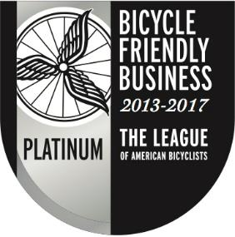
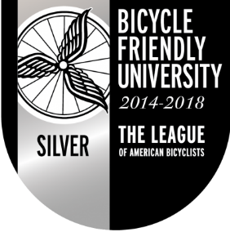
Email: Contact@BikeErie.org
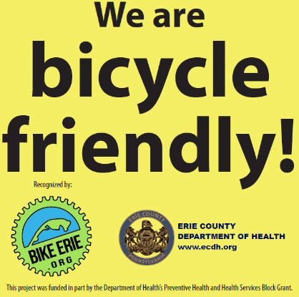

Sources:
- APBP: http://c.ymcdn.com/sites/www.apbp.org/resource/resmgr/publications/bicycle_parking_guidelines.pdf
- Dero: http://www.dero.com/bike-parking-guide.pdf
- VTPI: http://www.vtpi.org/tdm/tdm85.htm

